Multi-Factor Authentication Systems:
A Comparative Analysis of Four Industry Implementations

Team 00
Thao H. B. Bui – buithao1@cityuniversity.edu
Duy K. Bui - buikhanhduy@cityuniversity.edu
School of Technology and Computing, City University of Seattle
CS504_01_IN: Software Engineering
Professor Marcelo Guerra Hahn
August 23, 2026

Abstract

Multi-Factor Authentication (MFA) is a vital security measure for protecting account users against passwords theft or phishing. This team project analyzes and compares between four MFA implementations based on Authenticator Assurance Level (AALs) as defined in NIST Special Publication 800-63B. The team selects four authentication mechanisms ranging from simple to complex including: Memorized secrets combined with OTP/TOTP; Multi-Factor Cryptographic Software; Multi-Factor Cryptographic Device; and Federation and Assertions. By comparing these four mechanisms based on AAL assurance, the team will create a report regarding to the tradeoff between security and usability when choosing an appropriate MFA method for deployment.

Keywords: Multi-Factor Authentication, Authentication Assurance Level, Memorized Secrets, Cryptographic Authentication

- INTRODUCTION

Digital authentication is a core layer protection for most online services today. However, the most common method is a combination of username and password, which is the weakest link. It is especially vulnerable when users reuse the same password across multiple platforms. MFA was introduced to address this issue by combining two or more independent evidence such as what a user knows or possesses. In accordance with NIST Special Publication 800-63B, the AAL framework enables organizations to select an appropriate security level to their risk profile.

Based on this AAL framework, our team report presents four representative MFA methods ordered by increasing complexity. Four examples include memorized secrets combined with one-time codes (AAL2), cryptographic software such as WebAuthn/Windows Hello (AAL2), hardware-based cryptographic devices like the Titan Security Key (AAL2/AAL3), and federated identity authentication via OpenID Connect/Microsoft Entra ID (AAL1–AAL3). We then compare and choose to use the appropriate authentication method for our project.

- LITERATURE REVIEW

Many academic studies have shown that the fundamental weakness of single factor authentication is not only about technical aspects but also in user behavior. Das et al. (2019) through a systematic review of 623 academic papers on MFA, indicated that although MFA tools are very technologically advanced, user acceptance and actual usage remained highly barriers, require more specific users’ research to design a friendlier tool. This result is compatible with findings of De Cristofaro et al. (2013), who conducted research comparing usability of many different authentication technologies and saw that even though multi-factor authentication enhanced security, it also increased high cost for both providers and users.
The trade off between security and user experience from Amft et al. (2023), which focuses on account recovery when user loses access to second authentication factor like a mobile device or a hardware security key. This research also presses on recovery process undermines the entire MFA security process, bringing a critical challenge that systems like hardware security key or OTP must face.

At the industrial implementation level, Tran-Truong et al. (2025) conducted a systematic review on 70 academic papers and 13 commercial authentication tools, benchmarking with NIST SP 800-63 standards, especially AAL framework used in this team report. A notable finding is there is the significant gap between academic theory and implementation practices. Although more advanced authentication methods have widely been proposed in research, there is up to 33% of industry tools still rely primarily on OTP, a method standing at a lower level of assurance under the AAL classification. This finding reinforces that the selection of the four methods in sequence from AAL1 to AAL3 reflects not only the technical side but also the actual gap between widely used methods and that higher security but lower adoption use.

- METHODOLOGY

Our team project applies multifactor authentication using Flask, Flask-WTF, Flask-SQLAlchemy, SQLite, bcrypt and Flask signed session cookie. Below are the five applied mechanisms.

  - Cross-Site Scripting (XSS)

XSS appears when web inserted inputs are not trustworthy and run as JavaScript in another user browser. Our application displays login and registers through Jinja template in app/templates/. Jinja will auto escape template variables. Therefore, user input only appears as text instead of executable HTML or JavaScript. Usernames and error messages should never be displayed using |safe filter in Jinja.

  - Cross-Site Request Forgery (CSRF)
CSFR tricks user browser with a unintended state changing request while the authentication cookie is still valid. LoginForm and RegisterForm inherit from FlaskForm in app/main/forms.py. Flask-WTF will automatically protect CSFR for these forms. Template calls {{ form.hidden_tag() }} to embed the CSRF token. The form.validate_on_submit() method checks and validates the token before processing login or register.

  - SQL Injection

SQL injection appears when untrusted input combined with SQL statement in a way that changes the meaning of the query. Our team application uses Flask-SQLAlchemy in app/orm_query.py. Retrieving user via User.query.filter_by(username=username) treats username as a query parameter rather than the raw SQL code. Creating a new user using User and db.session.commit() help us avoid concatenating SQL strings from user input.

  - Router Decorators & Blueprint Architecture

Router Decorators connect one URL and HTTP method with a view function. Another different decorator can apply a general rule such as requiring a valid login session before the view executes. Blueprint main is created in app/main/__init__.py and registered within the app factory. Routes utilize decorator like @main.route(‘/login’, …). Protected routes additionally use @login_required, which check the valid username in the session or not. If not, decorator will redirect the user to /login.

  - Session Management

Session management controls how an application establishes, stores, authenticates, and terminates user login state. config.py defines SECRECT_KEY used by Flask to sign session cookie. After the username, password, and PIN have been authenticated successfully, the login view should store session[‘username’] = user.username. The @login_required will then request the cookie session before letting protected route access. Logout will clear session[‘username’] and redirect user to login page. In a production environment, the SECRET_KEY should be retrieved from a protected environment variable instead of hardcoded, and cookies should have HttpOnly, Secure, SameSite.

- ARCHITECTURE

Diagram 1 illustrates our overall application architecture. The user interacts with the frontend, which communicates with Flask backend. The backend then handles authentication logic, session management, and database access to support secure user operations.

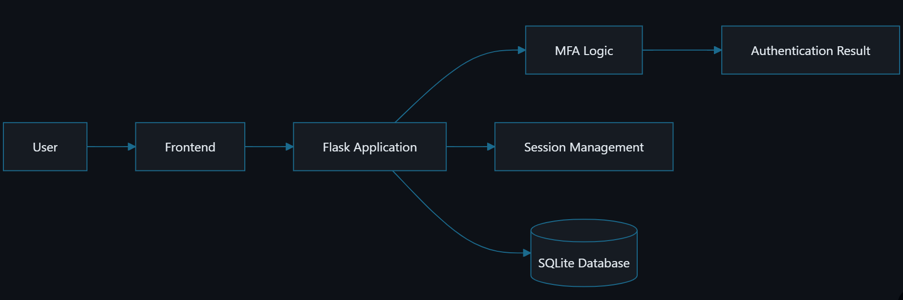
Diagram 1: Overall System Architecture
Diagram 2 illustrates our full authentication sequence between frontend, backend, and database.

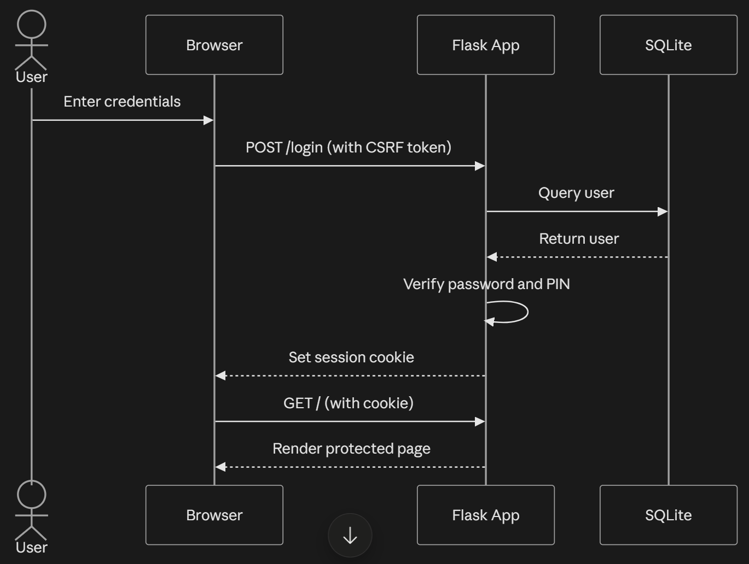
Diagram 2: Authentication Sequence
Diagram 3 illustrates our complete application modular structure.

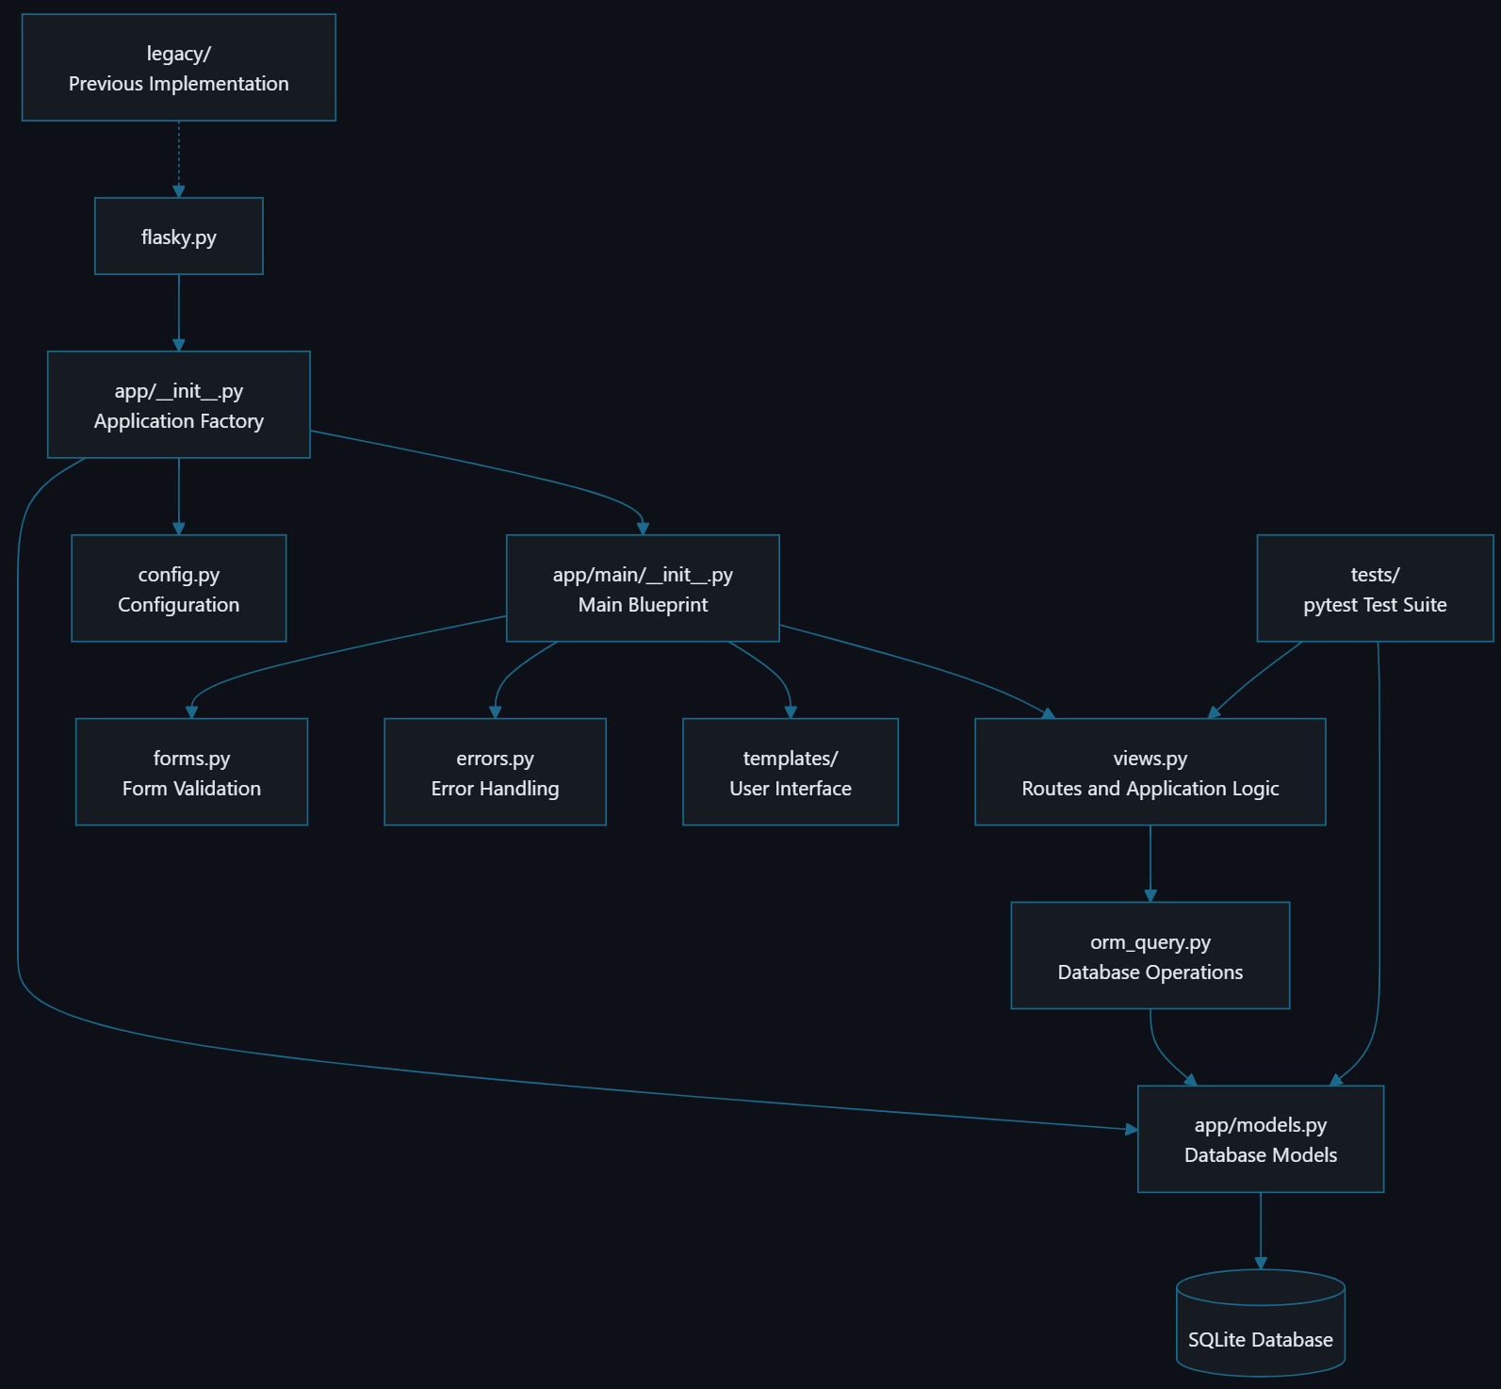
Diagram 3: Modular Structure of Whole Application

- REFERENCES

Amft, S., Höltervennhoff, S., Huaman, N., Krause, A., Simko, L., Acar, Y., & Fahl, S. (2023). "We've disabled MFA for you": An evaluation of the security and usability of multi-factor authentication recovery deployments. In Proceedings of the 2023 ACM SIGSAC Conference on Computer and Communications Security (pp. 3138–3152). ACM. https://doi.org/10.48550/arXiv.2306.09708
Das, S., Wang, B., Tingle, Z., & Camp, L. J. (2019). Evaluating user perception of multi-factor authentication: A systematic review. arXiv. https://doi.org/10.48550/arXiv.1908.05901
De Cristofaro, E., Du, H., Freudiger, J., & Norcie, G. (2013). A comparative usability study of two-factor authentication. arXiv. https://doi.org/10.48550/arXiv.1309.5344
D2L. (2026). About LTI 1.3 launch and authentication. Brightspace Community. https://community.d2l.com/brightspace/kb/articles/23730-about-lti-1-3-launch-and-authentication
Google. (n.d.). Titan security key. Google Cloud. Retrieved July 24, 2026, from https://cloud.google.com/security/products/titan-security-key
Grinberg, M. (2018). Flask Web Development. O’Reilly Media. https://ia903202.us.archive.org/31/items/python_ebooks_2020/Flask_Web_Development_%28en%29.pdf
Microsoft. (2023). Trusted Platform Module technology overview. Microsoft Learn. https://learn.microsoft.com/en-us/windows/security/hardware-security/tpm/trusted-platform-module-overview
Microsoft. (2026a). Introduction to Microsoft Entra tenants. Microsoft Learn. https://learn.microsoft.com/en-us/microsoft-365/education/guide/1-reference/introduction-microsoft-entra-id
Microsoft. (2026b). Set up Microsoft Entra ID. Microsoft Learn. https://learn.microsoft.com/en-us/intune/solutions/education/tutorial-school-deployment/setup-entra-id
Microsoft. (2026c). Web Authentication APIs. Microsoft Learn. https://learn.microsoft.com/en-us/windows/security/identity-protection/hello-for-business/webauthn-apis
Mozilla Developer Network. (n.d.). Web Authentication API. MDN Web Docs. Retrieved July 24, 2026, from https://developer.mozilla.org/en-US/docs/Web/API/Web_Authentication_API
Temoshok, D., Choong, Y., Regenscheid, A., Galluzzo, R., Fenton, J., Richer, J., & Lefkovitz, N. (2025). Digital identity guidelines: Authentication and authenticator management (NIST Special Publication 800-63B-4). National Institute of Standards and Technology. https://doi.org/10.6028/NIST.SP.800-63B-4
Tran-Truong, P. T., Pham, M. Q., Son, H. X., Nguyen, D. L., Nguyen, M. B., Tran, K. L., Van, L. C. P., Le, K. T., Vo, K. H., Kim Ngan, N. T., & Nguyen, T. M. (2025). A systematic review of multi-factor authentication in digital payment systems: NIST standards alignment and industry implementation analysis. Journal of Systems Architecture, 162, 103402. https://doi.org/10.1016/j.sysarc.2025.103402
- WORKLOAD ASSIGNMENT

Thao is responsible for application documents and suggestions of application architecture. Duy is responsible for main application code.

